| Team ID | PNT2022TMID37769 |
| --- | --- |
| Project Name | IOT Based Smart Crop Protection System for Agriculture |

IBM cloud services Dashboard

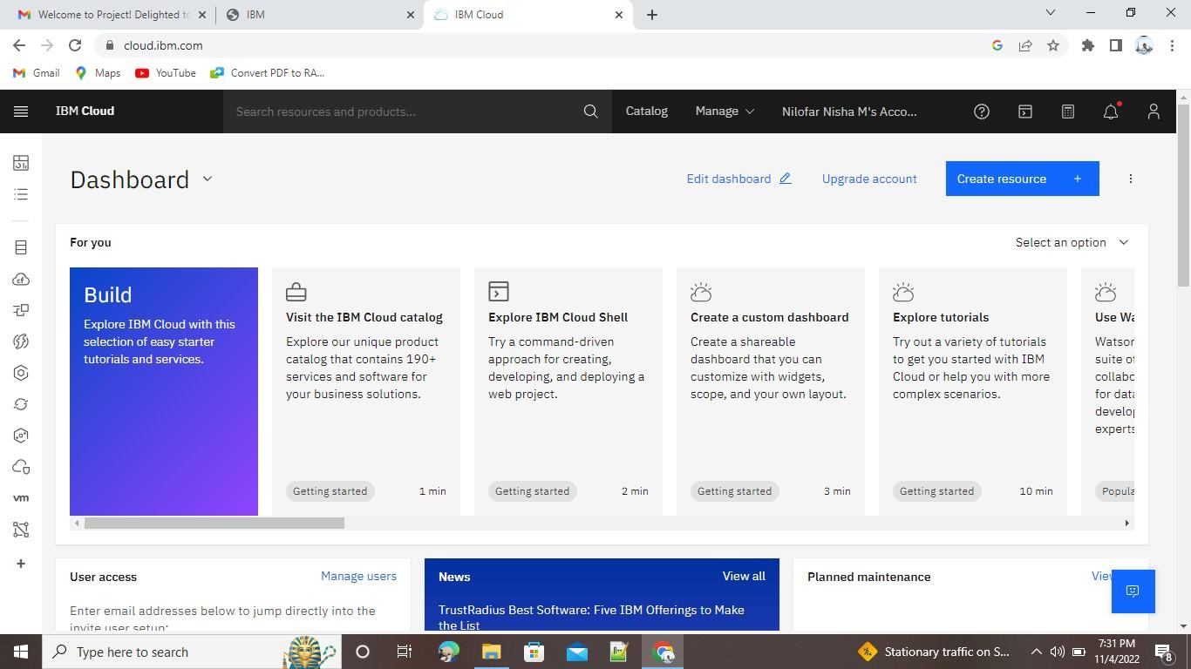

Account Settings

